**Pems Downloader:**

1. Update **Pems_config**
2. Update **Pems_Stations**
3. IP address- Chrome>Help>About Google Chrome
4. PHP: Inspect>Application>Cookies>PHP
5. PHP might change after session is logged off. Check once in a while
6. CMD prompt-

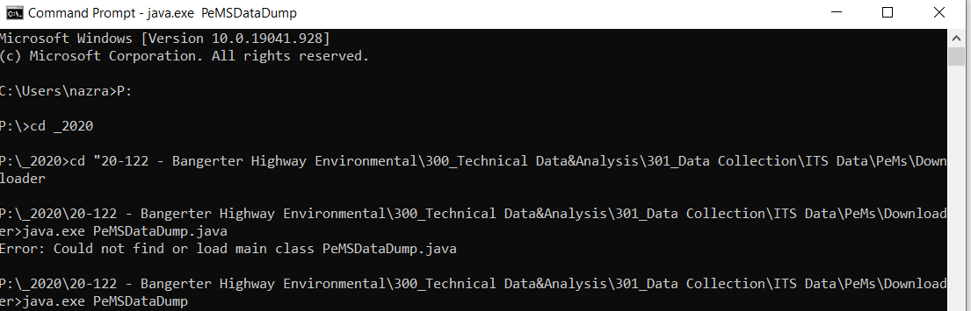

1. Java needs to be installed and up-to-date. If installed recently, computer needs restarting